WR WKn WB WQ WK WB WKn WR
WC WP WP WP WP WP WP WT

BC BP BP BP BP BP BP BT
BR BKn BB BQ BK BB BKn BR

I have a 2d string array that represents a chessboard (looks exactly like above). In my class that creates the graphics interface, I have a method that maps each string with an image icon. I then add all the image icons to my JPanel, which is added to my JFrame.

To check whether the graphics representation is correct, you can just compare it with the string array. For example, my string array has WR or white rook at the top left corner, and you can check whether there is a white rook on the top left corner of the graphics representation.

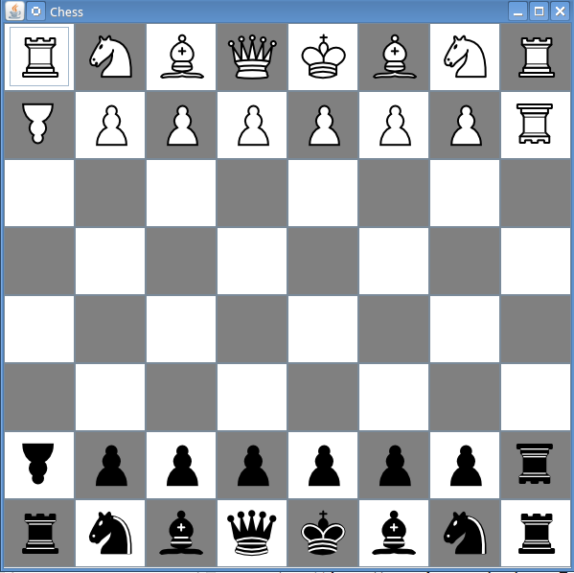

BC WKn WB WQ WK WB WKn WR
WC WP WP WP WP WP WP WT

BP BP BP BP BP BP BT
BR BKn BB BQ BK BB BKn BR

You can alter the 2d string array to further check that the graphics is represented correctly. To do this, you can use the public methods like capture() or move() for individual pieces. In this example, I used the capture() method to use my black cannon to capture the white rook.

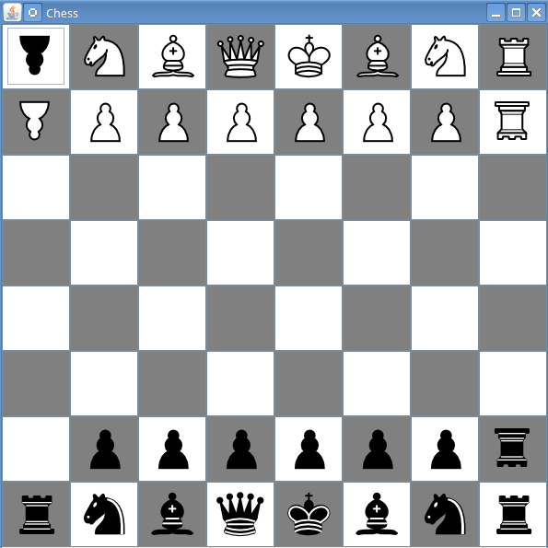

BC WKn WB WQ WK WB WKn WR
WC WP WP WP WP WP WP

WT

BP BP BP BP BP BP BT
BR BKn BB BQ BK BB BKn BR

Starting from the previous example, I also moved my white threeleaper down 3 spaces. You can compare the 2d string array with the board below.

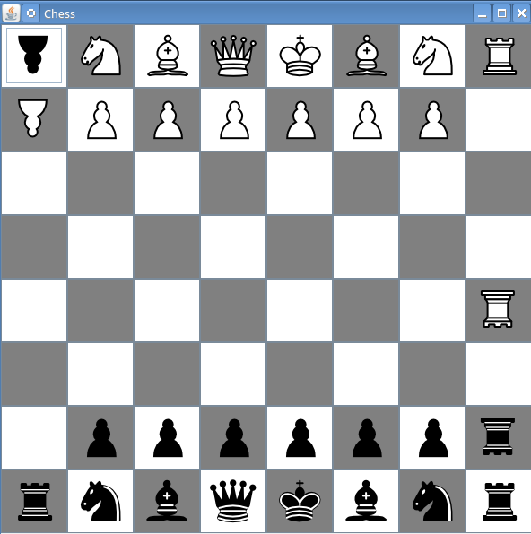

This is what the start menu should look like when you first load the game.
All 3 buttons should be functional. By clicking the player's name buttons, a dialog should pop up and request for an input string. It should look like the next page.

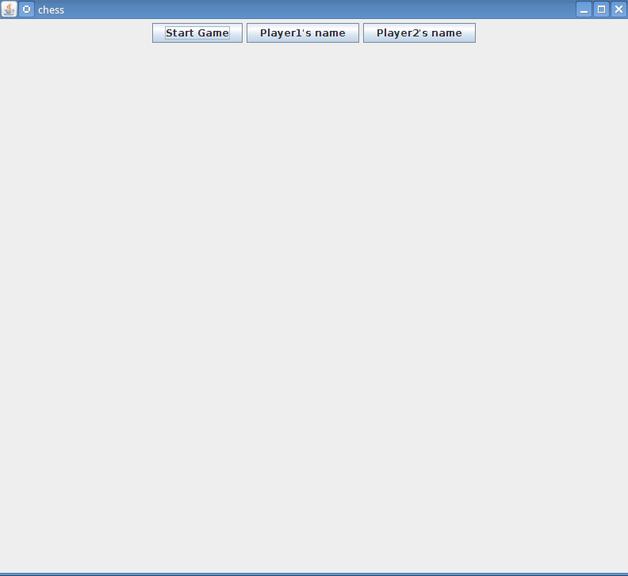

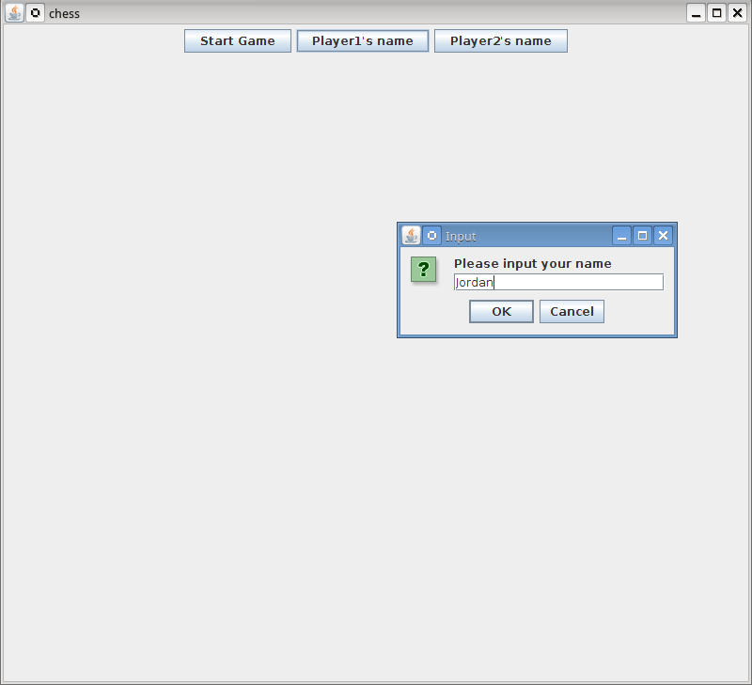
After pressing okay, the button should change from “Player1's name” into “Jordan.” You can enter an arbitrary string to test this. If there's something wrong, the problem is either in the message dialog method I called in mousePressed(), or there's something wrong in my Person class. If you choose not to input a name, when you start the game, the name should be “Anonymous.”
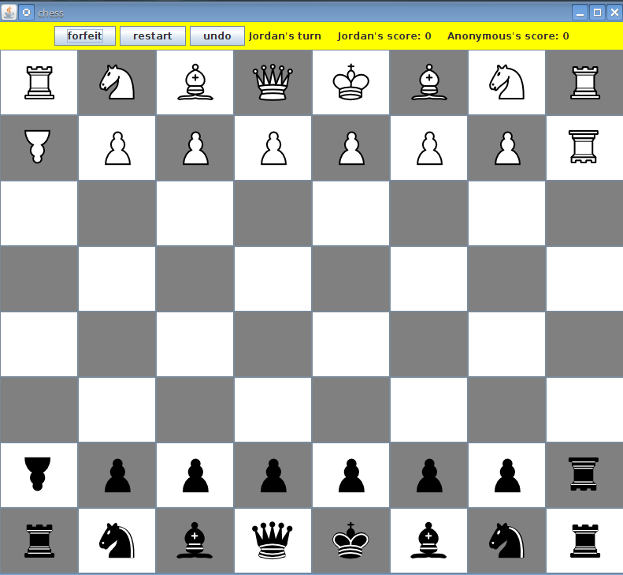
When you press start game, this is what you should see. If the chess pieces are not where they are supposed to be, there was a problem in initiating the start positions, and this should be in the Board constructor. From here, it starts as white's turn, or Jordan's turn. Jordan should only be able to move his white pieces.

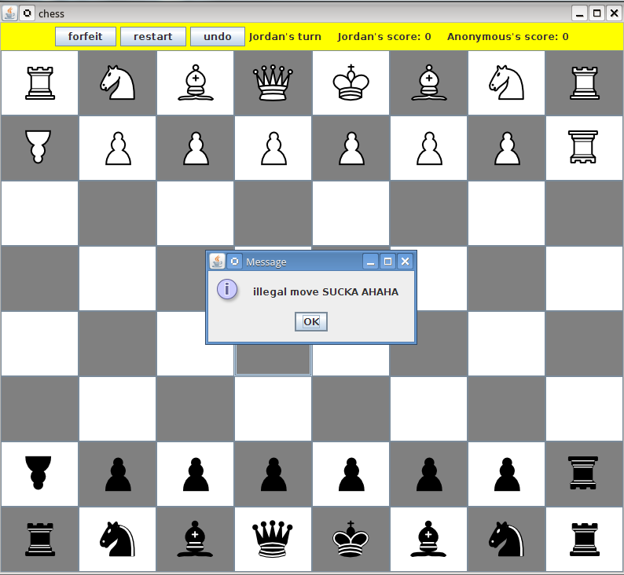
If Jordan tries to do an illegal move like going against a piece's actual moves or trying to move an opponent's piece, the dialog below should pop up. The game is resumed when “OK” is pressed.
After moving a piece, “Jordan's turn” should change into “Anonymous's turn” assuming player2's name was left unchanged. Moving and capturing work very similarly. The first click selects the piece. The second click selects the destination. If there's no chess piece at the destination, then the piece will try to move there. If there is a chess piece there, then it will try to capture it. If it's not a legal move, then the illegal move dialog should pop up again.

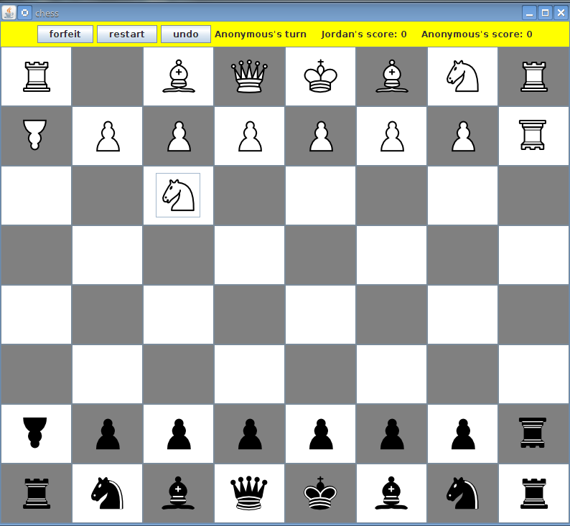

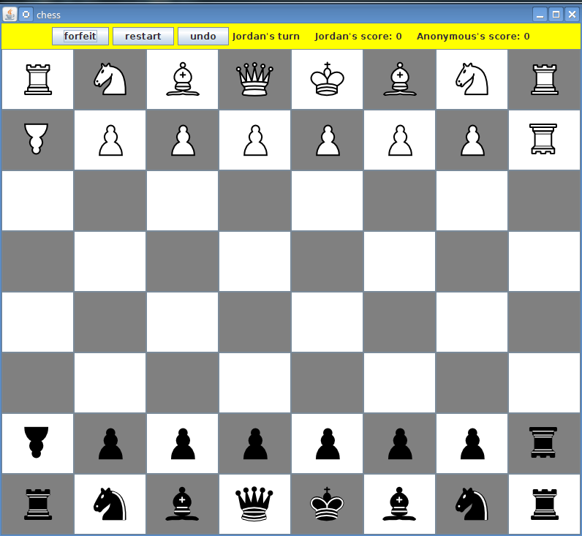
After pressing the undo button, the knight should go back to where it was previously, and the turn should go back to Jordan. If this is not the case, I might be pushing elements into the 2d string array stack at the wrong times.
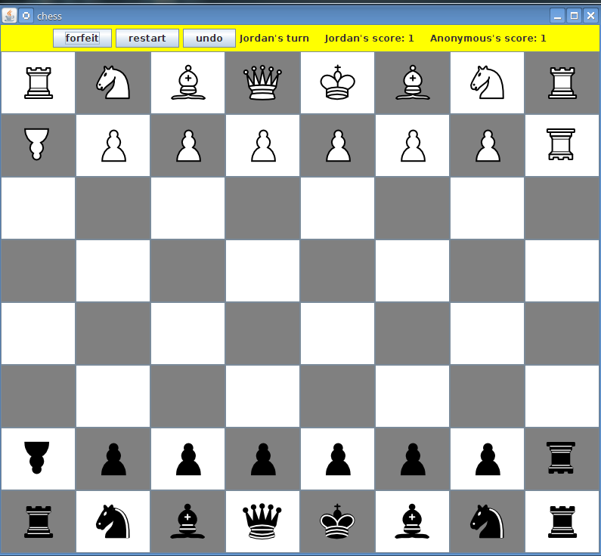
After pressing the restart button, the chess board should go back to its initial state. Each player's scores should go up by 1. If this is not the case, the error might be in the restart() function in ChessGraphics class

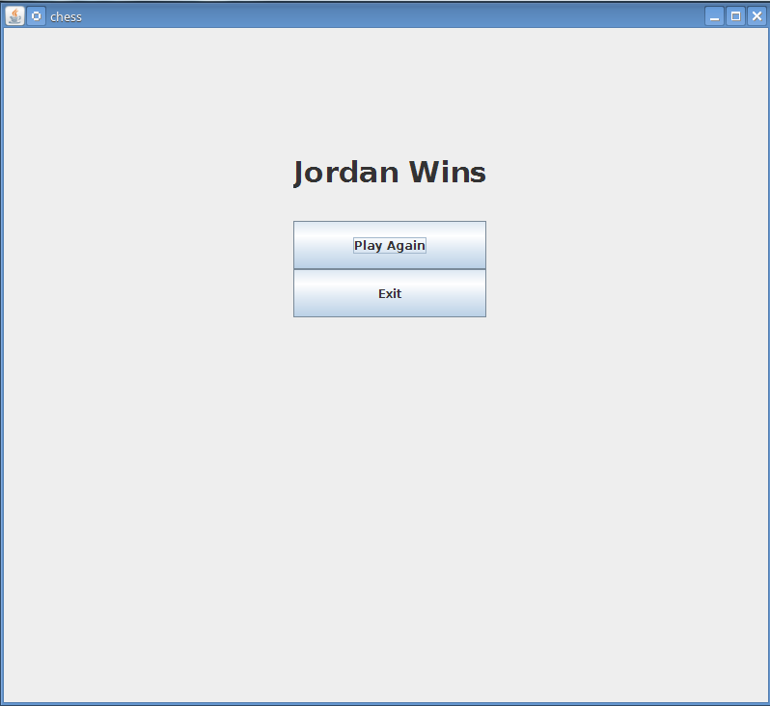
By clicking the forfeit button, you should be prompted by the gameOverPanel seen below. If Jordan forfeits, then the label should say “Anonymous Wins.” If player2 forfeits, then it should say “Jordan Wins.” If you press the exit button, the frame will close. If you press play again, the game will restart, but the winner will have his or her score incremented by one.

If the board is in this scenario, and I move my cannon to the right, above the pawn and king, then a checkmate dialog should appear.

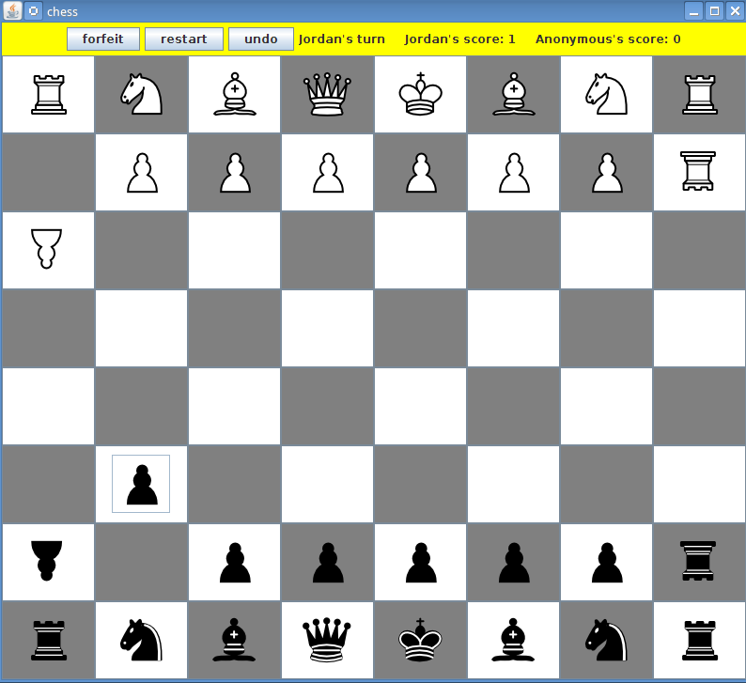

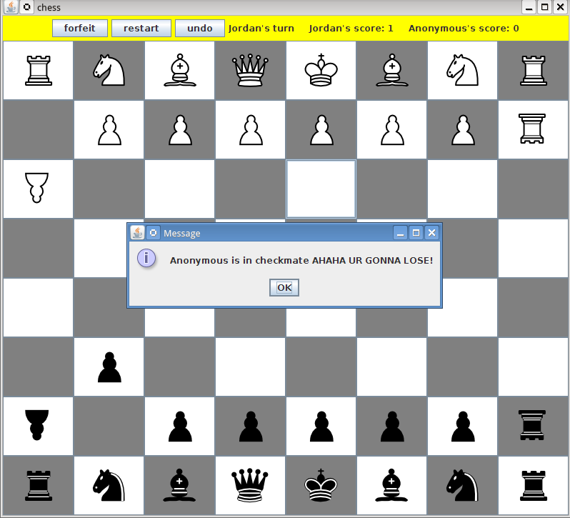
Notice that the dialog should appear before the piece is actually moved. A normal check works the same way, and you can create such a scenario by moving/capturing pieces.
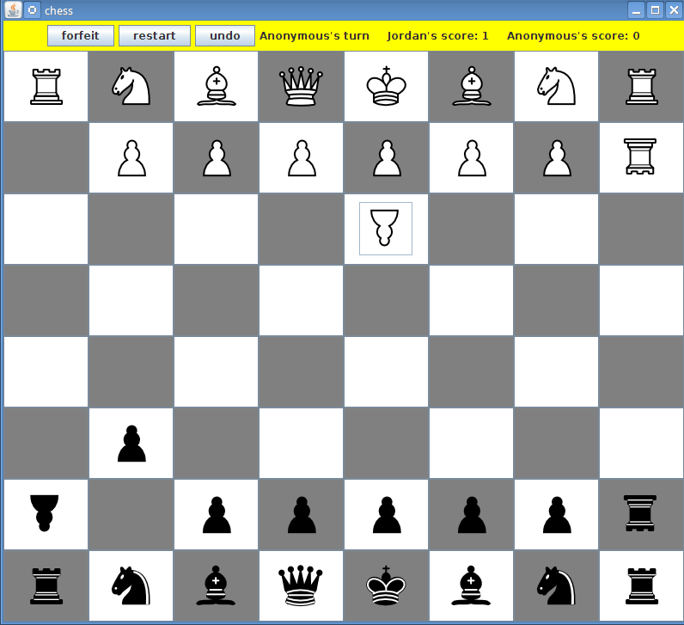
This is what it should look like after pressing okay in the checkmate dialog. Now it is Anonymous's turn and what ever he does, if player1 chooses to capture his king on his next turn, the player1 will win. If player1 chooses not to capture the king however, the game continues.

